Westile, Inc.

ScrewJack B-Series Specifications

Product Name– Bison Deck Supports (Westile ScrewJack)
Pedestal System Manufacturer
Bison Deck Supports, a United Construction Products Company

Westile, Inc. Phone 800-433-8453
An Oldcastle® Company Fax 303-791-9906
8311 West Carder Court www.westile.com
Littleton, CO 80125

Part 1 General
1.01 DESCRIPTION
- Scope
Furnish and install a complete adjustable deck support system with a maximum cavity height of up to 24 inches. Heights between 16 and 24 inches require approval in accordance with paragraph 3.03N-installation and added bracing described in paragraph 3.08. Bison Deck supports are not designed for supporting decks that carry vehicular traffic or equipment, (including but not limited to snow removal equipment, ATV’s, forklifts, or any motorized vehicles.)
  - Consult Westile, Inc. and/or an Engineer regarding the following:
    - When spacer tab condition or design requires spacing between decking tiles or concrete pavers other than the ScrewJack standard 3/16 inch spacing.
    - When considering use for other than a raised decks (e.g. interior floors, stairs, etc.).
    - When greater than 16 inch pedestal height is required.
    - When using ScrewJack pedestals on grade (soil).
    - When greater than 1,000lbs per pedestal load capacity is required.

- Related Work – the work includes but is not necessarily limited to:

  - Section 04 22 00 Concrete Unit Masonry
  - Section 04 40 00 Stone Assemblies
  - Section 04 41 00 Dry-Placed Stone
  - Section 07 50 00 Membrane Roofing
5. Section 07 72 46 Roof Walkway
- Section 07 76 00 Roof Pavers
Section 07 76 16 Roof Decking Pavers

7. Section 32 14 00 Unit Paving
Section 32 14 13 Precast Concrete Unit Paving
Section 32 14 13.16 Precast Concrete Unit Paving Slabs
Section 32 14 13.19 Porous Precast Concrete Unit Paving
8. Section 32 14 40 Stone Paving

1.02 SUBMITTALS
When requested by the architect or specifier, the installer shall submit, before the start of any work, a sample of the decking material and each component of the Bison Deck Support system that will be used in the project.

1.03 QUALITY ASSURANCE
Experience: The deck support system installer shall have a minimum of two (2) years proven construction experience and be capable of estimating & building from blueprint plans and details, determining elevations, material handling and the contractor agrees to comply with the installation application procedures for deck support work specified herein.

Over Waterproofing/Roofing: If the deck system is to be installed over a waterproofing or roofing membrane, the installer shall have a minimum of five (5) years successful roofing and waterproofing experience. The contractor must assume the responsibility for and take into consideration (1) the structural capability and adequacy of the structure to carry the dead and live load weight(s) involved, and (2) that the density of any insulation is satisfactory to resist crushing and damaging the waterproofing membrane.

After Installation Prior to Acceptance: The Owner, or the Owner’s Agent, shall carefully inspect the deck system to be positive that: (1) the new deck system is adequately blocked on all sides to contain the surface decking and related components, (2) that there is no more than tab width spacing between any deck panels and at all sides of the deck perimeter, (3) no ballasting rock is used to fill in any perimeter voids, or (4) that there is no ‘rocking’ of deck panels as foot traffic is applied to the surface decking, (5) that all required spacer tabs are in place and visible.

Proof of installer’s business experience shall be submitted in writing at the request of the architect.

1.04 Delivery, Storage, and Handling
- Deliver and store ScrewJack deck support system components with labels intact and legible.
- Inspect all delivered materials to insure they are undamaged and in good condition.

1.05 JOB CONSIDERATIONS
- Contractor and/or Owner shall assure that all current local codes are followed and met.
- There are no temperature restriction guidelines prescribed by Bison Deck Supports that limit deck installation work, other than the practical consideration of when a workman will not work due to inclement weather.
- Adequate edge containment with no more than a tab width space between the deck material and the edge containment barrier.

1 of 4
Decks over roofing and waterproofing:
- All membrane waterproofing and protection board surfaces to receive pedestals must be broom clean, frost free, and free of dirt, oil or any rough foreign matter that may impair the waterproofing/roofing manufacturers guarantee or protection requirements.
- The type and density of the substrate is of utmost importance. Refer to section 3.02 SURFACE PREPARATION.
- The substrate that is to receive pedestals must have slope and provide positive and adequate drainage in accordance with good building practice and applicable building codes.
- All four (4) sides of a deck system must restrain and contain the decking panels with perimeter blocking or walls. Decking panels must not be allowed to move or ‘walk’.

1.06 WARRANTIES / GUARANTEES
Westile, Inc. warrants that its products will remain free from defects for a period of three (3) years. The contractor shall warrant that his work will remain free from defects of labor and materials used in conjunction with his work in accordance with the general conditions for this project or a maximum of three (3) years. For use with pedestrian traffic only – never use ScrewJacks for motorized or equipment traffic – doing so will void the warranty. Decks with lateral movement in excess of one tab width (3/16 inch) will void the warranty.

PART 2 – PRODUCTS
2.01 GENERAL
All deck supports and accessories of the ScrewJack deck support system shall be obtained through Westile, Inc.

2.02 MATERIALS
- Product Model Nos. B1, B2, B3, B4 – ScrewJack Pedestals (Mineral Filled High Density Copolymer polypropylene)
- Rotating base 7 7/8 inch diameter x 3/16 inch top wall thickness, base bearing surface area (48 square inches), four (4) ea. 1/4 inch diameter holes for drainage and optional mechanical fixing.
- Top unit 5/32 inch thick plate with bearing surface area (29 square inches).
- Standard integral spacer tabs are 3/16 inch thick for uniform spacing between pavers.
- Maximum 1,000 lbs. per B Series ScrewJack Pedestal with a Factor of Safety of 2 (FS2)
- Product Model No. C4 - (Mineral filled high density copolymer polypropylene)
- Product Model No. B11 - Rubber Pads, Shims. (EPDM) 1/16 inch thick.
- Product Model No. PS1 - Rigid Polypropylene Shims, 1/8 inch thick.
- Product Model Nos. PS8, PS9 - Fixed height pedestal supports. (Mineral filled high density copolymer polypropylene) 1/2” and
3/4” inch high, base bearing surface area thirty four (34) square inches with 1/8 inch spacer tabs.
- Product Model No. LD4 - Base Leveler Disk (Mineral filled high density copolymer polypropylene) Built in slope is ¼ inch per foot; center point thickness 3/8 inch; used individually or stacked in multiples, and placed underneath the pedestals, the LD4 compensates for substrate slopes up to 1 inch per foot.
- Product Model No. PH5 - Top mounted Adjusting Leveler Disk (Mineral filled high density copolymer polypropylene). Used for precise top leveling with incremental adjustment from zero to 5/8 inch per foot.

2.03 PHYSICAL PROPERTIES
A. Nos. B1, B2, B3, & B4 ScrewJack Deck Supports, Nos. C4 Coupling Unit, Nos. PS1, PS8, PS9 Fixed Height Pedestals, No. LD4, No. PH5, Mineral Filled High Density Copolymer Polypropylene No. B11 Rubber Pads Fabric Reinforced EPDM Rubber
B. Characteristics
1. Mineral Filled High Impact Copolymer Polypropylene
a. Brittleness Temperature - ASTM D 746
b. Softening temperature of plastics - ASTM D 1525
c. Shore Hardness - ASTM D 1706
d. Ozone Resistant
e. Load bearing Capacity. Each Bison ScrewJack Pedestal shall support a maximum of 1,000 lbs, with a Safety Factor of 2.
2. EPDM
a Tensile strength and elongation - ASTM D 412
b. Tear resistance - ASTM 624
c. Resistance to water absorption - ASTM D 471

PART 3 - EXECUTION
3.01 GENERAL
Inspect the substrate to ensure that it has been properly prepared to accept the deck supports. Any surface projections which may impair the performance of the ScrewJack deck supports shall be appropriately removed or repaired. Commencement of work shall imply acceptance of surfaces.

3.02 SURFACE PREPARATION
General:
A. The substrate surface that will receive the deck supports must be well compacted or structurally capable of carrying the dead and live loads anticipated. The substrate shall be clean and free of projections and debris that could impair the performance of the pedestals or the total deck system.

Roofing & Waterproofing Decks:
A. Insulation above the membrane: (Option 1) Insulation and/or protection board (if specified) must be applied over the waterproofing substrate and/or specified drainage mat. Install the system according to the membrane manufacturer’s recommendations and specifications.
1. Insulation Over Membrane: “Closed-Cell” polystyrene insulation with a minimum compression strength of 60 psi density is recommended for any insulation that is placed immediately under ScrewJack Deck Supports to prevent crushing damage to the insulation and waterproofing systems, as well as an uneven pedestal surface.
2. Protection Board: (for asphalt type systems used over waterproofing) Full coverage 1/8 inch asphaltic composition protection board is recommended. When protection is specified only under the pedestal cut protection board pads to extend beyond the outside perimeter of the pedestal base by a minimum of one (1) inch.
2 of 4
3. Drainage Mat: (when desired or specified) Install drainage mat according to the manufacturers recommendations to avoid crushing.
B. Insulation below membrane: (Option 2) Insulation required to be installed within a roofing system below deck supports must meet the roofing membrane manufacturers’ specifications and must have a minimum core density of 60 psi.
1. Specify and require insulation that has a 60 psi or greater density in order to adequately support a ScrewJack Pedestal.

3.03 DECK SUPPORT APPLICATION
Preparation:
A. Installation requirements vary for each individual project site. Deck materials used, pattern, grid layout, starting point, and finished elevation should be shown on plan view shop drawings which have been prepared and approved by the designer, installing contractor and/or owner. Measurements from the construction site should be used for final ScrewJack selection and purchasing.
C. The finish deck surface elevation is typically determined at the door threshold and will utilize the shortest ScrewJack. Once a starting point and the finished elevation of the deck surface have been determined, the ScrewJack or "top of pedestal" elevation is established and marked on the perimeter wall using a transit “torpedo” water level or laser leveling device.
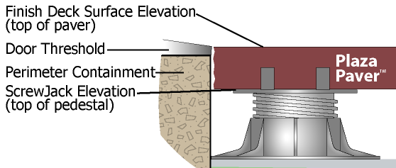

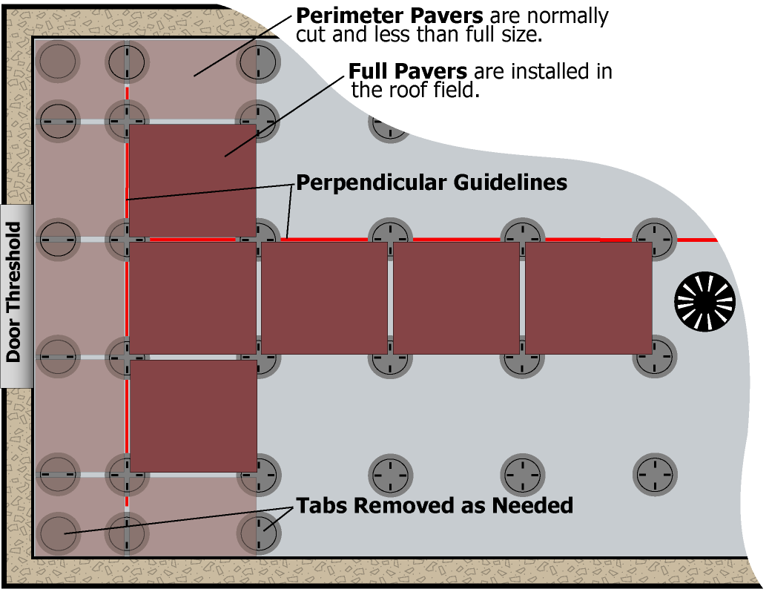
D. Precise measurements should be taken and deck area should be accurately defined. Install two (2) lines that are perpendicular to each other across the deck area with chalk lines or spray paint.
1. First line is parallel to perimeter wall, and the distance from the wall is determined by the perimeter pavers' width or length.
2. Second line must be perpendicular to first line and serves as a control line for square installation. Placement of second line should be marked along the pavers' edge.
To ensure a square layout, use additional control lines as references to periodically check the layout during installation.
Installation:
E. Do not install first row of pavers at perimeter wall; begin installation of full pavers at the second row in the roof field. Install initial pavers along guidelines forming a “T” pattern. Install remaining field pavers out from T”.
F. Install perimeter pavers last. Perimeter pavers are normally cut and less than full size. When installing ScrewJacks along perimeter, remove two (2) spacer tabs in line with one another on top of each ScrewJack placed around the perimeter. Remove all four (4) spacer tabs at corners.
G. Adjust each ScrewJack to a “top of pedestal” elevation marked around the perimeter. Using the “top of pedestal” elevation marked on the perimeter, stretch a mason’s line along and slightly ahead of the second row of deck supports. A laser leveling device may also be used for this purpose. Normally the ScrewJack is positioned as close to the perimeter as possible, with the two remaining spacer tabs. Base flange can be trimmed for close fit at perimeter.
H. On larger decks, it is recommended that ScrewJack models be pre-selected and pre-set to the proper elevation and placed in position prior to the installation of pavers or tiles.
I. As the ScrewJacks are loaded with pavers, fine vertical adjustment can be made by rotating the base or bottom of the deck support. Clockwise rotation of the pedestal base will raise the bearing surface and the deck. Counter-clockwise rotation will lower the bearing surface.
J. If the “safety windows” located at the base of the screw cylinder become visible, it indicates that the ScrewJack is extended beyond the minimum required engagement of threads. A coupling unit C4 must be added to achieve the desired height. Never use a pedestal when the safety windows are exposed.
K. Slight irregularities in decking panel thickness can be compensated for by using one or more B11 rubber shim wedge segments. Place on top of the pedestal, under the corner(s) of the paver. Use no more than two (2) shims and always adhere quarter (¼) wedges with construction adhesive.
L. For elevations below 1 1/4", use Fixed Height Pedestals: Model Nos. PS8 (1/2”), and PS9 (3/4”). Stack no more than two (2) fixed height pedestals together and place in lieu of adjustable pedestals where needed. Spacer tabs can be removed to accommodate perimeter and corner support locations. Acceptable shimming methods for Fixed Height Pedestals vary from Adjustable pedestals: use up to three (3) B11 (1/16" rubber) shims directly under Fixed Height Pedestals and apply up to two (2) PS1 (1/8" rigid) shims on top of Fixed Height Pedestals. If elevations are below 1/2" (model PS8), stack B11 shims and use 3/16" spacer tab.
M. Slope Compensation:
1. Preferred Method: Model LD4 base leveler disk should be used to level the pedestal base. Place one or more Disks under the ScrewJack pedestal base to compensate for up to 1 inch per foot of slope. Compensate for slope by placing the disks’ thickest edge (located on the edge by a small finger tab) at the down slope side of the ScrewJack, one disk compensates for ¼” inch per foot of slope. Using two or more disks, rotate one in relation to the other to create a level and plumb ScrewJack.
2. Shims may be used in multiples, whole or segmented, and placed under the base to level the deck support. All shims under a pedestal must be adhered with construction adhesive. Model B11 rubber shims: Use no more than two (2) shims. Model PS1 plastic shims: Use no more than one shim under a pedestal.
3. Use top mounted adjusting leveler disk, PH5, to compensate for slopes up to 5/8” per foot. Turn the top leveler disk to expose a number from 1 to 5 in the sight window (1 = less slope, 5 = more slope). Locate the arrow on the top of the leveler disk that corresponds to the number in the sight window. Place the ScrewJack deck support so that the numbered arrow points directly downhill.
N. If a specifier requires and desires to install a cavity deck system over the height of 16” up to a maximum of 24” in height, special approval is required prior to commencing the installation. The installing contractor must furnish Westile Inc. the proposed design for the extreme height bracing, stamped by a professional, licensed engineer. Special written approval will then be furnished by Westile, Inc. to the installing contractor with a copy to the specifier, prior to commencing any pedestal and decking work. (Refer to 3.08 BRACING DESIGN REQUIREMENTS below.)

3 of 4
3.04 SCREWJACK PLACEMENT AND FINAL ADJUSTMENT
ScrewJacks and the pavers must be placed as the manufacturer directs in these written instructions. Use of labor saving devices, such as paver lifters, is encouraged, especially on large jobs. ScrewJack pedestals are designed to be rotated for final slight adjustment when pedestals are fully loaded. ScrewJacks should be leveled in each succeeding row as the installation proceeds. Final height adjustment or maintenance is easily made by simply rotating the base in a clockwise or counter-clockwise direction to raise or lower the panel. Sections of B11 shims may also be used and should be available for regular maintenance. Shims may be used in multiples, whole or segmented, and placed under the base to level the ScrewJack. All shims under a pedestal must be adhered with construction adhesive.

3.05 PERIMETER CONTAINMENT
Any area of a ScrewJack deck that is not restrained by a parapet or foundation wall must be ‘boxed-in’ and contained. The deck panels will move if all sides are not adequately restrained. Perimeter framing and edging boards located at the outside of the deck perimeter must be installed to provide restraint. No movement should be allowed at the perimeter of the deck system greater than one tab width (3/16") for ScrewJack. Any cumulative movement in excess of one tab width will void the Warranty.

3.06 FIELD QUALITY CONTROL
Inspect often during installation to ensure guidelines are being maintained in a straight and consistent pattern and that deck panels or pavers are level and not rocking. Confirm that deck pedestal height does not exceed sixteen (16”) inches in height. Confirm that pedestal heights in excess of 16” have been braced and that proper authorization has been received. Unless otherwise specified in writing to allow for expansion, inspect to ensure all paver spacing between tiles and at perimeter walls does not exceed a tab width. Particular attention should be made to ensure all pedestrian entry or access points to the deck are level and that the deck surface tiles are not randomly raised or uneven creating a tripping or safety hazard.

3.07 ROUTINE MAINTENANCE & CARE
The deck owner must perform routine maintenance of the deck. Check for rocking pavers and adjust or shim immediately. Pedestals can settle and may have to be realigned. Failure to do so can cause a tripping hazard. Periodically check spacer tabs and immediately replace broken tabs to limit deck movement. Make sure the edge restraint stays intact and structurally sound.

3.08 BRACING DESIGN REQUIREMENTS

SCREWJACK BRACING DESIGN REQUIREMENTS FOR INSTALLATION OVER 16 INCHES IN PEDESTAL HEIGHT
ScrewJack pedestal combinations over 16 inches up to a maximum of 24 inches (16”- 24”) must have adequate horizontal bracing installed in both directions and located at three (3) evenly spaced height locations.
Option One: Insert ¾” thick Pretreated CDX plywood pre-cut bottom braces, approximately 1 ¾” wide by 19 ½” long between pedestal columns in both directions. The lower bracing must be installed as cross bracing, utilizing an ”X” pattern, and be installed both directions of the columns. Bracing must be located and secured on all bottom and middle couplers. In addition, one single horizontal brace must be installed at the height of all top and bottom couplers. All bracing must be in both (two) directions. Bracing must be installed to tightly restrain the ScrewJack pedestals columns from moving. The bracing must be secured through the provided coupler eyelets.

Option Two:

Insert ¾” thick Pretreated CDX plywood pre-cut bottom braces, approximately 1 ¾” wide by 19 ½” long between pedestal columns in both directions. These create the bottom horizontal bracing. Insert the decking panels (concrete pavers) into their normal and horizontal position at the top of the 4’ x 4’ cluster of four panels. When the set of four panels and their columnar pedestals are tightly banded together, these panels serve as the top horizontal bracing. Using a 3/4” banding strip, wrap the 4’ x 4’ cluster at the coupler. Using a banding strip, ratchet tighten the banding until taught, being careful not to over tighten. Secure banding clips where the two ends meet using a crimper. Interlock next 4’x4’ cluster with the first one and continue for all pedestals 16” - 24” in height.
Contact Westile for approval in accordance with paragraph 3.03N-installation.
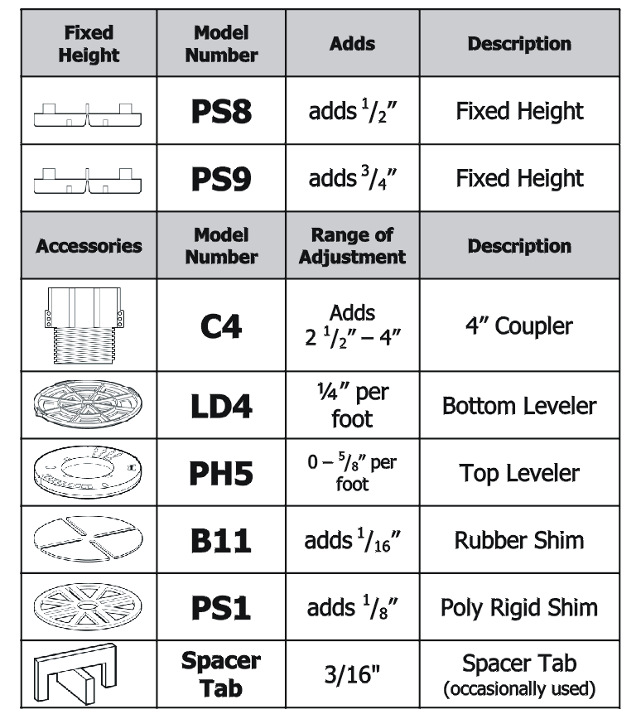
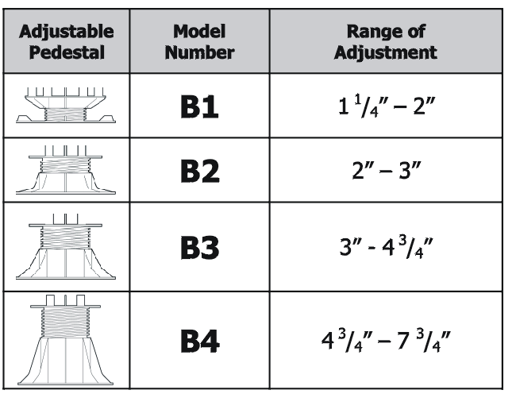


Westile, Inc.
An Oldcastle® Company
8311 West Carder Court
Littleton, CO 80125
Phone 800-433-8453
Fax 303-791-9906
www.westile.com

4 of 4

