
SENTINEL
Embedded Galvanic Anodes

Note: The paragraphs below are meant to be incorporated into Parts 2 and 3 of a standard CSI 3 Part Format specification, project’s General Structural Notes or directly onto the plans. They must be carefully reviewed by a qualified design professional and edited to meet the particular requirements of the project at hand, assure compliance with any governing building codes, and coordinate with other specification sections and drawings. In no case shall these Guide Specifications be considered to be Contract Documents or serve as installation instructions for the product being discussed. In any case of discrepancy, the manufacturer's most recently published data sheet shall take precedent.

SECTION 03 70 00 EMBEDDED GALVANIC ANODES

{Note to Specifier: This section covers The Euclid Chemical Company “Sentinel” anodes which are designed to mitigate the corrosion of reinforcing steel in concrete. Consult Euclid for assistance in editing this section for the specific application.}

- GENERAL

      - RELATED SECTIONS
        - Drawings and general provisions of the Contract, including General and Supplementary Conditions and Division 1 Specification Sections, apply to this Section.
        - Section 03 30 00 - Cast-in-Place Concrete.
        - Section <<insert section>> - Concrete Repair.

      - SUMMARY

        - This Section includes furnishing all labor, materials, equipment and service necessary to properly install Galvanic Anodes designed to mitigate corrosion of reinforcing steel in concrete.

      - SUBMITALS
        - Make submittals in accordance with requirements of Division 1 and as specified in this Section.
        - Submit samples of anode(s) and related materials at least <<insert number>> days in advance of installation.

        - Manufacturer’s Certification: Submit manufacturer’s ISO 9001/9002 certification.

        - Product Data: Submit manufacturer’s product data, including surface preparation and placement instructions.

        - Comply with Section 01330 - Submittal Procedures.

      - QUALITY ASSURANCE

        - Manufacturer’s Qualifications: ISO 9001/9002 registered or provide proof of documented quality assurance system. Quality assurance system shall be registered by independent registrar accredited by ANSI Registrar Accreditation Board (ANSI-RAB) or by another internationally recognized body.

{Note to Specifier: Describe requirements for a meeting to coordinate the placement of the anode and to related work.}

        - Pre-placement Meeting: Convene a pre-placement meeting <<insert number>> days before start of placement of concrete repair mortar. Require attendance of parties directly affecting work of this section, including contractor, Engineer, and manufacturer’s representative. Review surface preparation, placement, protection and coordination with other work.
        - All galvanic anodes, galvanic anode accessory parts and materials, shall originate from a single manufacture.
        - All repair mortars used in repairs containing galvanic anodes shall originate from same source manufacture as galvanic anodes.

{Note to Specifier:: Euclid Sentinel Anodes can be placed in portland cement based materials with a maximum volumetric resistivity of 30,000 ohm/cm (at 28 days 70 deg F and 80 percent RH) utilizing a spacing factor (see spacing recommendations in this document). Other manufacturers may require a maximum volumetric resistivity of 15,000 ohm/cm.}

The following Euclid repair mortars are compatible with Sentinel galvanic anodes and can be specified in your concrete repair section. Contact Euclid Chemical to obtain Guide Specifications for each of the products. EUCOREPAIR CP, EUCOREPAIR V100, EUCOCRETE, EUCOPATCH, CONCRETE-TOP SUPREME, VERTICOAT, EXPRESS REPAIR, TAMMS FORM & POUR, SPEED CRETE PM, TAMMS STRUCTURAL MORTAR, NS GROUT (fluid) and EUCOSHOT
        - Repair mortars, concrete and bonding agents shall be Portland cement-based materials with volumetric resistivity below 30,000 ohm/cm @ 28 days, 70 deg F. (21 deg C) and 80 percent RH. Provide submittals confirming resistivity of repair materials prior to beginning work. Non-conductive repair materials such as epoxy, urethane, or magnesium phosphate are not permitted.

      - DELIVERY, STORAGE, AND HANDLING

        - Delivery: Deliver materials to site in manufacturer’s original, unopened containers and packaging, with labels clearly identifying product name and manufacturer.

        - Storage: Store materials in clean, dry area in accordance with manufacturer’s instructions. Keep containers sealed until ready for use. Avoid extreme temperatures.

        - Handling: Protect materials during handling and placement to prevent damage or contamination.

- PRODUCTS

      - Materials

        - Galvanic Anodes

          - Description: Pre-manufactured concrete casing containing zinc, around a pair of galvanized steel tie wires designed to mitigate corrosion of reinforcing steel in concrete.
          - Current: Anode will have a current output equal to or greater than 1.0 milliamps at 90 days. when tested at 70 deg F and 50 percent relative humidity in a concrete block containing not more than 0.7ft2 (0.028m2) of reinforcing steel.
          - Designed with special V-notch design configuration that snugly fits rebar, requiring no special training.
          - Galvanic anode shall incorporate insulating barrier at interface of anode and reinforcing bar to prevent “dumping” of current into attachment bar there by extending coverage area and service life of galvanic anode.
          - In compliance with ASTM C418 Type II, ASTM A82 and ASTM B6/B69
          - Basis For Design:

{Specifier Notes: Choose from (3) Sentinel series products listed in sub paragraphs below. Products have varying quantities of zinc which will determine spacing of units. See spacing guidelines published by manufacturer. Sentinel Gold eq. 200 grams zinc, Sentinel Silver eq. 100 grams zinc, and Sentinel GL eq. 38 grams zinc.}

            - [Sentinel-GL available from The Euclid Chemical Company.(www.euclidchemical.com)]
            - [Sentinel-Silver available from The Euclid Chemical Company.(www.euclidchemical.com)]
            - [Sentinel-Gold available from The Euclid Chemical Company.(www.euclidchemical.com)]

        - Repair Mortars Compatible with Galvanic Anodes
          - Horizontal Repair Mortar: Shall be prepackaged, cementitious repair mortar Repair mortar shall be capable of achieving a minimum 3 day compressive strength of 3,000 psi and 5,000 psi at 28 days per ASTM C 109, as certified by manufacturer, Manufacturer to provide written certification of compatibility with galvanic anode corrosion protection system.
- Basis for Design:
              - Eucopatch, Euco-Speed, or Express Repair by The Euclid Chemical Co. (www.euclidchemical.com)
          - Vertical Repair Mortar: Shall be prepackaged, cementitious repair mortar Repair mortar shall be be capable of achieving a minimum 1 day compressive strength of 3,000 psi and 8,000 psi at 28 days per ASTM C 109 as certified by manufacturer, volumetric resistivity of less than 12,000 ohms/cm @ 28 days, and maximum 1100 coulombs Chloride Permeability when tested per ASTM C 1202. Manufacturer to provide written certification of compatibility with galvanic anode corrosion protection system.

- Basis for Design:
              - Verticoat or Tamms Structural Mortar by The Euclid Chemical Co. (www.euclidchemical.com)
          - Form and Pour/Pumpable Repair Mortar: Flowable one-part, high strength silica fume modified repair mortar with 0.375 in. aggregate. Product shall achieve 9000 psi at 28 days at a 9-inch slump. Manufacturer to provide written certification of compatibility with galvanic anode corrosion protection system.
            - Basis for Design
              - “Eucocrete” or “Tamms Form and Pour” by The Euclid Chemical Co.

- EXECUTION

      - EXAMINATION

        - Examine surfaces to receive anode. Notify Engineer if surfaces are not acceptable. Do not begin placement until unacceptable conditions are corrected.

      - SURFACE PREPARATION
        - Concrete removal and preparation of concrete surface for repair shall be conducted according to Section <<insert section number>>.
          - Remove all unsound concrete from around and behind steel reinforcement.
          - Provide minimum ¾” clearance between anode and substrate or ¼” larger than top size aggregate of repair material, whichever is larger.
          - Clean exposed reinforcing steel to remove all rust, mortar, etc. Provide bright-metal surface that will provide sufficient electrical connection.
          - Secure loose reinforcing steel by tying tightly to other bars with steel tie wire. Newly secured reinforcing steel shall be tested to ensure electrical continuity according to the following paragraph.
        - Confirm electrical continuity of the reinforcing steel within the repair area through the use of a high-impedance multi-meter. Correct electrical discontinuity (a resistance reading greater than 3.0 Ohms) by wiring discontinuous bars to adjacent bars using steel tie wire.

      - PLACEMENT

        - Place anodes as close as practical to edge of repair area (within 6” or 150 mm) while providing sufficient clearance for anode to be completely surrounded by repair mortar.

{Specifier Notes: Insert appropriate anode depth of cover below based on recommendations of ACI 318 Building Code Requirements for Structural Concrete}

Concrete cast against permanently exposed earth- minimum 3”

Concrete exposed to earth or weather -
No. 6 through No. 18’s minimum 2”
No.5 W31 or D31 wire or smaller minimum 1.5”

          - Minimum [1.5][2][3] inches of repair mix cover shall be provided over galvanic anode unit.
          - Where possible install Anode with top face parallel to concrete surface. Anode may be angled down in cases where concrete cover is very shallow.
          - Position the SENTINEL anode’s patented grooved insulator firmly against any size rebar and securely fasten anode in place using the integrated tie wires. On each side, wrap each of the wires at least once around the rebar in opposite directions, then bring the ends of the wires together.
          - Grip wires with pliers or other suitable tool and steadily twist wires, firmly securing anode to rebar. Do not Over-tighten as this may result in breakage of wires.
          - After installation, check electrical continuity between anode tie wires and the rebar, using a high impedance multi-meter. A resistance reading of 3.0 ohms or less indicates adequate continuity. If resistance is too high, remove anode, clean rebar thoroughly and repeat installation procedure. Bend excess twisted wires down onto rebar.
          - If rebar coatings are used, coat reinforcing steel after installation of anodes, taking care not to apply any coating to anode itself. In this case, electrical continuity between the anode wires and the rebar must be checked thoroughly.

{Specifier Notes: Anode spacing shall be as specified by the designer, but anode spacing should not exceed 30” (750mm) on center. Guidelines for anode placement spacing are presented below}

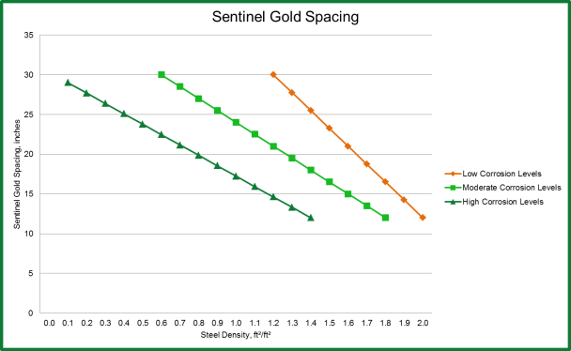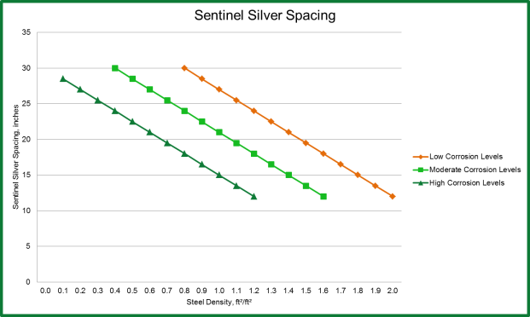

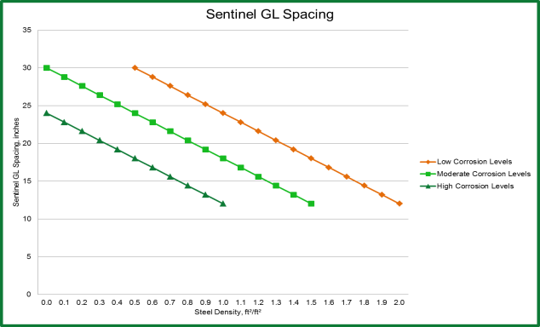

{Specifier Notes: The density of the reinforcing steel is the total surface area of the bar (ft²) within a square foot of concrete (regardless of depth).

Corrosion levels in the concrete can be broken into three measurable categories based on ASTM C-1152 Acid-Soluble Chloride of Mortar and Concrete: Light corrosion levels: < 4 lb/yd3, Moderate corrosion levels 4 to 8 lb/yd3 and High corrosion levels: > 8 lb/yd3

In the event the volumetric resistivity of the repair material is higher than 15,000 ohm-cm, a spacing correction factor must be used. If the resistivity is higher than 15,000 ohm-cm and equal to or less than 20,000 ohm-cm, a correction factor of 0.9 must be used. If the repair material is greater than 20,000 ohm-cm and equal to or less than 30,000 ohm-cm, a correction factor of 0.7 must be used. For example: the anode spacing has been determined to be 24 in. (61 cm) due to the corrosive environment the concrete is in and the steel density within the concrete. However, the resistivity of the repair material is 25,000 ohm-cm. Therefore, the spacing would be 24 x 0.7 = approx. 17 inch (43 cm) spacing.

B. Anodes shall be spaced [as indicated on dwgs] [at <<insert number>> inches on center.]

    - PROTECTION

        - Anodes shall be installed and covered as soon as possible after removal from their original sealed packaging. Any anodes removed from their original packaging must be protected from excessive moisture and/or contaminants until time of repair material placement.

        - Do not allow anodes to freeze.

END OF SECTION

