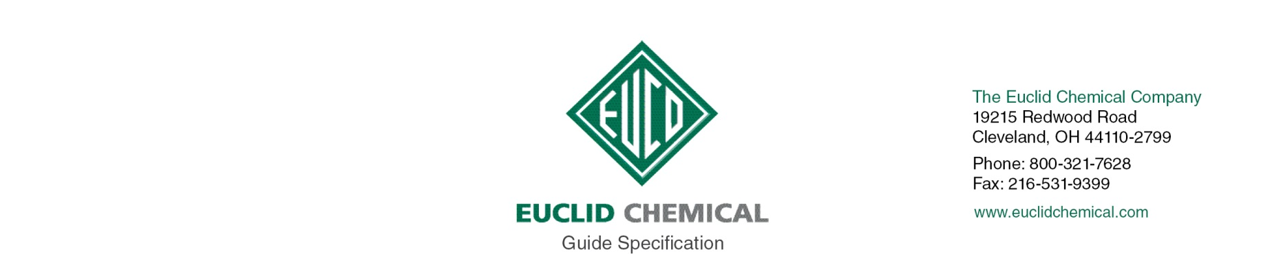
Super Diamond Clear VOX
Non-Yellowing Curing and Sealing Compound (Water-Based)

SUPER DIAMOND CLEAR VOX is a high solids, water-based acrylic curing and sealing compound. This product provides a quality cure to freshly placed concrete while assuring total resistance to yellowing from ultraviolet exposure.

{Note to Specifier: The paragraphs below are meant to be incorporated into Parts 2 and 3 of a standard CSI 3 Part Format specification, the General Structural Notes, or directly onto the plans. They must be carefully reviewed and edited to meet the requirements of the project and governing building codes. Coordinate with other specification sections and drawings.}

PART 2: PRODUCT

2.__ CURING AND SEALING COMPOUND

A. Concrete curing and sealing compound. A ready-to-use, water-based acrylic curing and sealing compound for use on new and existing, interior and exterior, horizontal and vertical concrete surfaces. Product shall conform to:
ASTM C 309, Type 1 Class A & B and ASTM C 1315 Type 1 Class A.
AASHTO M 148 Type 1
1. Product:
- Euclid Chemical Company (The); Super Diamond Clear VOX www.euclidchemical.com

2.__ Manufacturer shall have ISO 9001 Quality Certification. To ensure compatibility all products shall be from the same manufacturer.

PART 3: EXECUTION

3.__ EXAMINATION

A. When used on existing concrete, examine concrete surfaces to receive curing and sealing compound. Notify specifier if surfaces are not acceptable. Do not begin surface preparation or application until unacceptable conditions are corrected.

3.__ SURFACE PREPARATION

A. When used on existing concrete, prepare concrete surfaces in accordance with manufacturer’s written instructions.

B. Ensure surfaces are clean and free of standing water.

C. Remove dirt, dust, oil, grease, sealers, and other materials that may prevent adhesion of curing and sealing compound.

3.__ APPLICATION

A. For the best cure of freshly placed concrete, apply SUPER DIAMOND CLEAR VOX as soon as possible after finishing operations and/or immediately after the disappearance of the “sheen” of surface moisture.

B. Apply curing and sealing compound to concrete surfaces in accordance with manufacturer’s written instructions.

C. Apply compound at uniform coverage rate in accordance with manufacturer’s written instructions.

D. Apply as soon as possible after finishing and immediately after disappearance of surface moisture sheen, when used to cure freshly placed concrete.

E. Do not apply to concrete to receive toppings, epoxy coatings, urethane coatings, or epoxy adhesives.

F. Do not use as a bond breaker for tilt-up construction.

G. Do not dilute curing and sealing compound.

H. Cure concrete surfaces as specified in Section 03300.

